Full Stack Development with MERN
Project Documentation format
1. Introduction
• Project Title: DarshanEase
• Team Members:
Shivam Angral – Component Selection & System Design
Sayali Gaikwad– Backend Development
Urvendrasingh Sisodia – Frontend Development
Ayush Shahre – Database Design

2. Project Overview
• Purpose: DarshanEase is a web-based platform developed using the MERN stack (MongoDB, Express.js, React.js, and Node.js). The system allows devotees to book temple darshan slots online instead of waiting in long queues at temples. The application provides a convenient way for users to browse temple information, check available darshan slots, and reserve their preferred time.
The project aims to improve the overall temple visit experience by reducing waiting time and improving crowd management through an online booking system.
Features:
- User registration and login
- Browse temples and view temple details
- Check available darshan slots
- Book darshan slots online
- View booking history
- Online donation system
- Admin dashboard for temple and slot management
3. Architecture
The system follows a three-tier architecture consisting of frontend, backend, and database layers.
• Frontend: The frontend of the application is developed using React.js. It provides an interactive and responsive user interface where users can browse temples, book darshan slots, manage bookings, and make donations. React components are used to structure the UI and manage application state.
• Backend: The backend is built using Node.js and Express.js. It handles application logic such as user authentication, temple management, slot booking, and donation processing. The backend exposes RESTful APIs that communicate with the frontend.• Database: MongoDB is used as the database to store application data such as users, temples, darshan slots, bookings, and donations. Mongoose is used to define schemas and interact with the MongoDB database.
4. Setup Instructions
• Prerequisites:
Before running the application, ensure the following software is installed:
- Node.js
- MongoDB
- npm (Node Package Manager)
Installation:
- Clone the project repository
- Install dependencies
npm install
- Configure environment variables in the .env file
- Start the backend server
- Start the frontend application

- Folder Structure

The project is divided into two main folders.
• Client: Contains the React application.
Main folders include:
- components – reusable UI components
- pages – main application pages
- services – API communication
- context – state management

• Server :
Contains the Node.js backend.
Important folders include:
- controllers – business logic
- routes – API endpoints
- models – MongoDB schemas
- middleware – authentication middleware
- config – database configuration

6. Running the Application
• To run the project locally, both frontend and backend servers must be started.
Frontend
Run the following command inside the client directory:
npm start
Backend
Run the following command inside the server directory:
npm start
After starting both servers, the application can be accessed through a web browser.
7. API Documentation
• Authentication APIs
- POST /api/auth/register – register new user
- POST /api/auth/login – login user
Temple APIs
- GET /api/temples – retrieve temple list
- GET /api/temples/:id – get temple details
Booking APIs
- POST /api/bookings – create booking
- GET /api/bookings – retrieve booking history
Donation APIs
- POST /api/donations – create donation record
8. Authentication
• Authentication is implemented using JSON Web Tokens (JWT).
Key features include:
- Secure login using JWT tokens
- Password hashing for data security
- Middleware verification for protected routes
This ensures that only authenticated users can access certain functionalities of the system.

9. User Interface
• The application provides a clean and responsive interface.
Main pages include:
- Home page
- Login and registration pages
- Temple listing page
- Temple detail page
- Booking history page
- Admin dashboard
The UI is designed to be simple so users can easily navigate and book darshan slots.

10. Testing
• Testing was performed to ensure the system functions correctly.
Testing types used:
- Functional testing
- User acceptance testing (UAT)
The following features were tested:
- User registration and login
- Temple browsing
- Darshan slot booking
- Donation functionality
- Admin management
11. Screenshots or Demo
Screenshots of the application interface are included to demonstrate the system functionality.
Home Page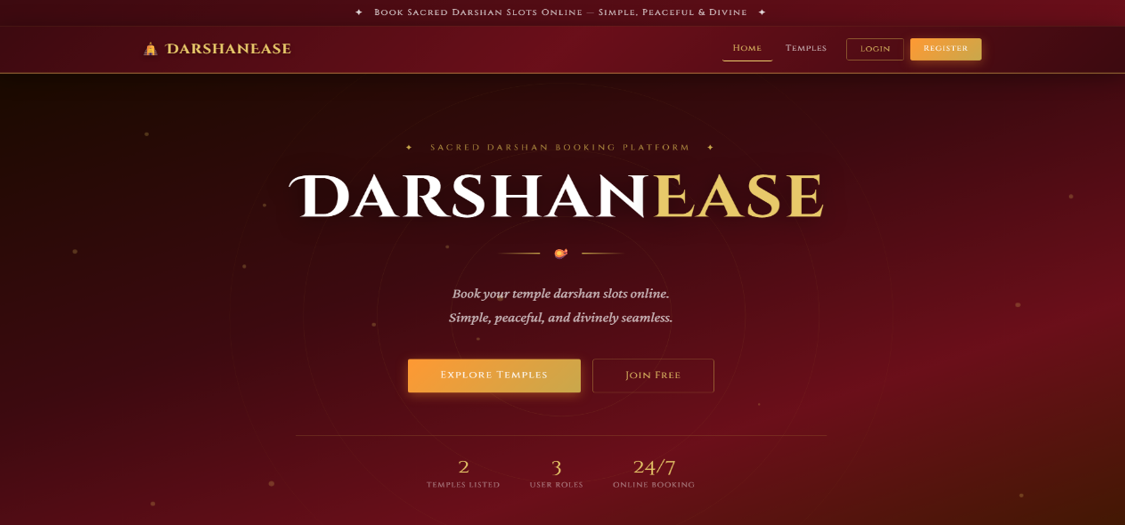
Temple Listing
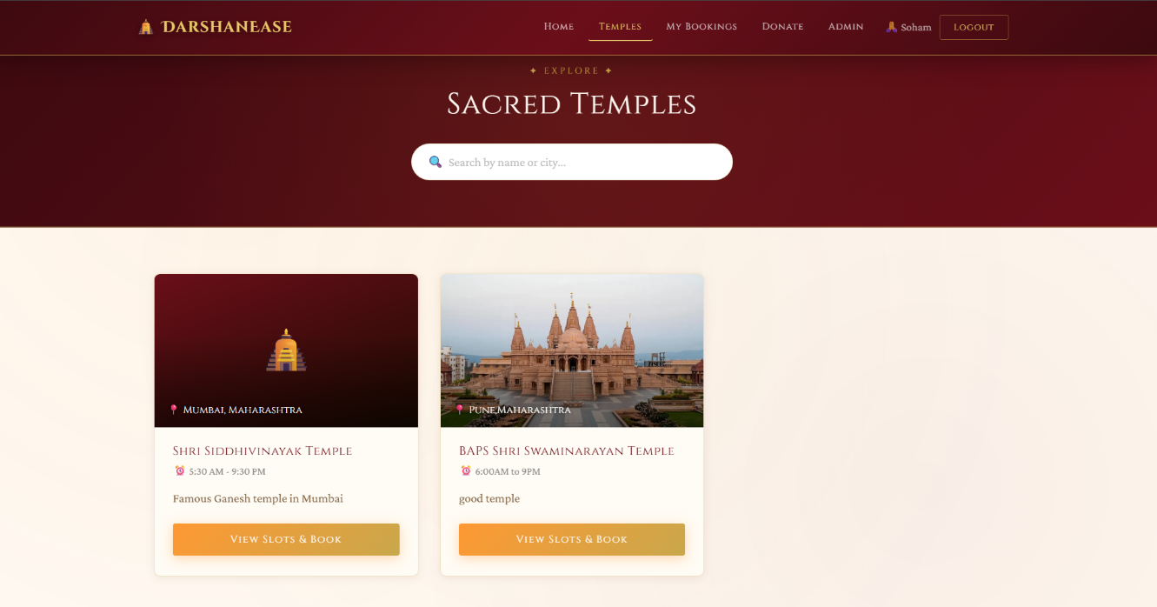
Temple Detail & Booking
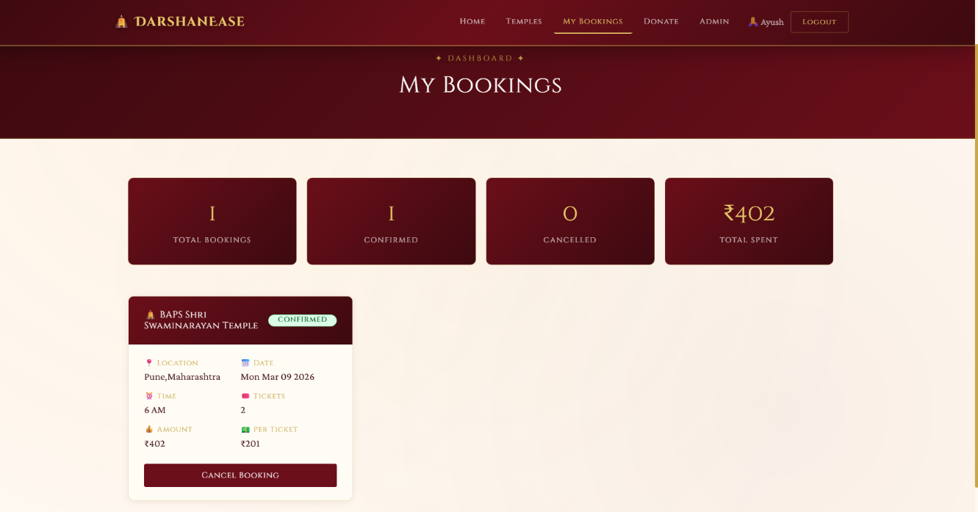
Admin Dashboard
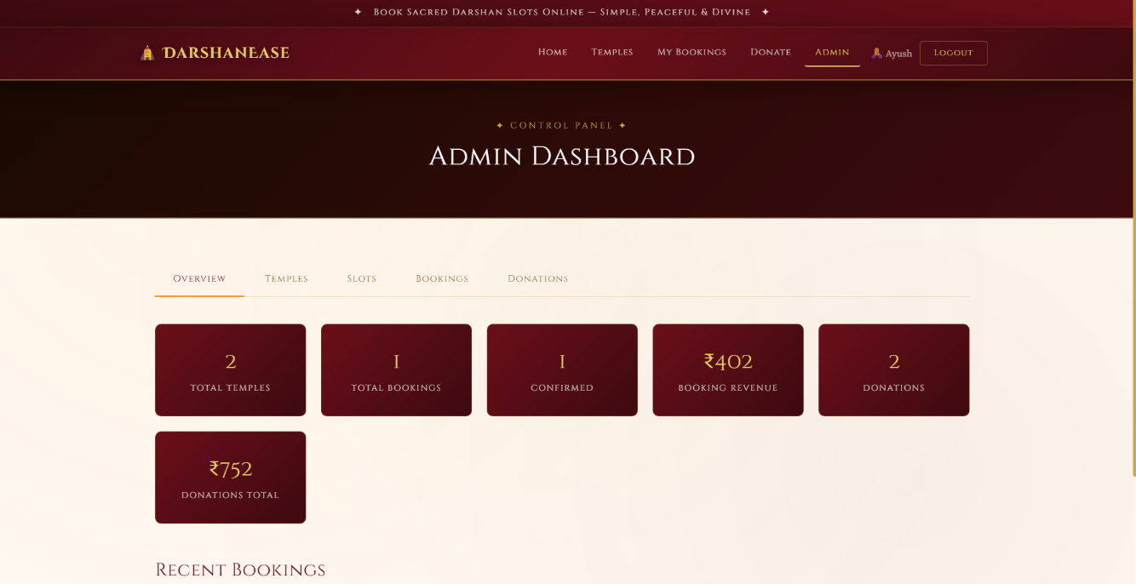

12. Known Issues
• Some minor issues may occur depending on network conditions.
Examples include:
- Slow loading of temple images
- Delayed API responses on poor internet connections
These issues can be optimized in future updates.

13. Future Enhancements
• The system can be improved with additional features in the future.
Possible enhancements include:
- Mobile application version
- Payment gateway integration
- Multi-language support
- Advanced analytics for temple management

